# ABSTRACT

Smart Serve (The Canteen Order System) is a software solution to solve the draw backs of traditional order system in canteen and enhance the dining experience in canteens by leveraging modern software solutions.

The Project aims to bridge the gap between canteen operators and their customers, increasing the efficiency, and communication of the order processing. It provides features like real time menu browsing, and queue management for chefs. The system also facilitates customer satisfaction by including features like order tracking, customer ratings.

Connecting every stakeholder, be it a customer, or  any canteen personnel, through a single portal enables Smart Serve to develop mutual understanding and easiness.

# ACKNOWLEDGEMENT

This project would has been possible with the help and guidance of many individuals, despite the significant efforts from our side.

We would like to extend our sincere thanks to all. We are indeed grateful to the Asian College of Higher Studies (ACHS) and its members for the support, supervision, and providing necessary resources and information to accomplish this project. We would also like to extend our heartfelt gratitude to our supervisor, Mr. Basanta Jung Karki, for his cooperation and guidance, which were of huge importance for the successful progress and completion of this project.

Additionally, we express our special thanks and appreciation to our lecturers, friends, and several individuals whose help and encouragement have been crucial throughout this project.

Table of Contents

ABSTRACT 1

ACKNOWLEDGEMENT 2

INTRODUCTION 5

1.1 Introduction to proposed project 5

1.2 Problem Statement 6

1.3 Objectives 6

1.4 Scope and Limitation 6

1.4.1 Scope 6

1.4.2 Limitation 7

1.5 Report Organization 7

BACKGROUND AND LITERATURE REVIEW 9

2.1 Background Study 9

2.1.1 Create New Account 9

2.1.2 Login 9

2.1.3 Surfing 9

2.2 Literature Review 10

SYSTEM ANALYSIS AND DESIGN 11

3.1 System Analysis 11

3.1.1 Requirement Analysis 11

3.1.2 Data Modeling (ER- Diagram) 13

3.1.3 Process Modelling (DFD) 14

3.2 System Design 16

IMPLEMENTING AND TESTING 18

4.1 Implementation 18

4.1.1 Tools Used 18

CONCLUSION AND FUTURE RECOMMENDATION 19

5.1 Conclusion 19

REFERENCES 20

APPENDICES 21

List of Figures

Figure 1: Use case Diagram 11

Figure 2: ER Diagram 13

Figure 3: Level 1 DFD 14

Figure 4 Level 2 DFD 15

Figure 5 Flow Chart (User) 16

Figure 6: Flow Chart (Admin) 17

# INTRODUCTION

## Introduction to proposed project

"Smart Serve" is a concept of a canteen management system to manage ordering, preparing, and serving the items within the canteen more effectively. The system supports automated order processing; customers may submit orders avoiding contact or long waiting queues. At the time of its introduction, "Smart Serve" reduced communication delays among customers, kitchen personnel, and waitstaff with accurate information about real-time status of orders and the availability of items. Automated order processing systems significantly enhance the efficiency of canteen operations by reducing wait times and improving order accuracy [1].

"Smart Serve" serves as an interactive digital interface for the customers to access the menu, place orders, and monitor preparation times. The system captures the ratings, and allows administrators to easily manage the order flow, and edit menu options. This facilitates efficiency, transparency, and ultimately increases customer satisfaction in canteen operations. Mobile based application for ordering emphasize the importance of user-friendly interfaces in digital food ordering systems, which contribute to a better overall dining experience[2].

The primary focus of "Smart Serve" is to give a refreshing boost to traditional canteen services while making it an interactive process, easy for customers as well as employees. Automated notifications and integrated workflows ensure efficient service delivery.

The "Smart Serve" system will allow customers to avoid the hassles of manual ordering, queuing, and disappointment of item unavailability. The proposed system addresses common inefficiencies related to canteen services, making it especially relevant to high-tempo environments such as college campuses, workplaces, and public areas.

## Problem Statement

In Nepal, traditional canteens often face inefficiencies in their order-taking, food preparation, and delivery processes. The use of manual ordering systems leads to errors in communication, delays, and dissatisfied customers. These are further worsened by the following factors:

1. Crowds during peak hours, which lead to delays and mismanaged orders.
2. No structured queuing mechanism by which culinary staff can then prioritize.
3. The absence of an effective tracking system for payments often results in discrepancies in accounts.
4. The failure or nonuse of modern technology to enhance efficiency and better the customer experience.

## Objectives

The main goal of the Smart Serve (The Canteen Order System) project is to extend canteen capabilities by providing a smooth and easily accessible digital ordering interface that incorporates the following features:

1. To facilitate the customer in viewing the menu and placing an order with ease.
2. To enhance the processing of orders by reducing errors and lowering the interaction time between staff and customers.
3. To enable real-time monitoring of the statuses of order preparation and delivery.
4. To provide administrators with useful insights into sales and performance through structured data visualization.
5. To ensure a seamless experience for users at all levels of technological proficiency with an intuitive interface.

## Scope and Limitation

Scope

1. Users can browse through the digital menu and view item availability, placing orders conveniently.
2. Real-time updates enable customers to trace their order status.
3. Offers a simple, yet effective platform for administrators to manage and improve operational activities.
4. Engineered with usability in mind, making it accessible to people of all experience levels.
5. It not only reduces human error but enhances overall customer experience.

Limitation

* Some basic features like detailed analytics of customer behavior and predictive suggestions are missing in the current version.
* Limited initial capacity: The system will have a fixed menu and predefined categories at the start; it is designed to be scalable in further iterations.
* Limited user reviews: Mechanisms for customer feedback are not yet implemented in this version of the demo.

## Report Organization

This project report is organized into five chapters as follows:

**Chapter 1: Introduction**

This document provides a detailed overview of the Smart Serve (The Canteen Order System) project, including its objectives, scope, and limitations.

**Chapter 2: Literature Review**

This section covers the basic research on analogous systems, their strengths and weaknesses, and outlines the gaps in the current solutions that this proposal attempts to address.

**Chapter 3: System Analysis and Design**

The architecture of the system is elucidated, encompassing Requirement Analysis and Feasibility Analysis. Furthermore, it delineates both the structural and functional designs of the system, providing an overview of the project's developmental process.

**Chapter 4:** Implementation

Focuses on the development process, implementation methodologies, testing strategies, and debugging procedures to ensure the system works as intended.

**Chapter 5: Conclusion**

It summarizes the results and achievements of the project, its limitations, and identifies the potential areas for future development and improvements.

# BACKGROUND AND LITERATURE REVIEW



## Background Study

In today's busy world, the application and access to the internet have grown in such a way that people can easily do normal tasks online. With convenience and efficiency taken into consideration, Smart Serve or The Canteen Order System is an application designed to simplify ordering in canteens, just like how hotel reservation systems simplify room booking for guests. Below are general ideas embedded in these applications.

2.1.1 Create New Account  
Simple registration will help users create an account with us, which will, in turn, allow them to access special features like order tracking and history.

2.1.2 Login  
After creating the account, users can log in to the system with their e-mail and password, where all functions offered are securely available.

2.1.3 Surfing  
Once authenticated, one can browse the variety of dishes or menu options available, therefore allowing a user to see what options are available to them before ordering.  
  
2.1.4 Sequencing  
After selecting food items in the menu, users can place an order. The system makes sure that only available items are displayed in order to prevent conflicts.  
  
2.1.5 Logout

When users have completed the step of placing an order, they logout from their accounts to keep all the information secure after the food order has been completed. This system offers an integrated experience, improving efficiency and saving both time and effort for users.

## Literature Review

The digital food ordering system is a simple tool for users to provide a better dining experience. The implementation of food ordering systems has become an essential part of modern dining experiences, aiming to streamline the ordering process, reduce errors, and increase customer satisfaction. Various approaches to food ordering systems have been employed over the years, each with its own advantages and challenges. This literature study examines the drawbacks of traditional food ordering systems, handheld device systems, and tablet-based ordering systems.

### Traditional Food Ordering System

Traditional food ordering systems in canteens rely on manual processes, including taking orders by hand, communicating them to the kitchen, and handling cash transactions. This approach often results in long wait times, order inaccuracies, and inefficiencies in managing menu updates. The traditional ordering system brings inconvenience to both staff and customers as it requires a lot of manual work. The manual work done by the staff can cause human errors such as lost paper orders and misinterpreted handwriting, leading to customer dissatisfaction and a poor dining experience. The existing traditional order management system does not facilitate easy updating of menu and causes delay[3].

### Tablet-Based Ordering Systems

Tablet-based systems place a tablet at each table, allowing customers to place orders directly without waiter intervention. While this method reduces errors associated with manual order-taking, it requires significant investment in hardware and can be cumbersome to manage. These systems also often suffer from issues with menu updates and integration with existing kitchen workflows [4].

### QR Code Based Digital Ordering Systems

SmartServe differentiates itself by providing a web-based platform accessible via QR codes, eliminating the need for manual order-taking, reducing the hassle of using keyboards to order, and reducing the potential for human error. Unlike traditional systems and handheld devices, our system allows for real-time menu updates and order tracking, enhancing both accuracy and efficiency. It also avoids the need for expensive hardware investments by leveraging users' personal devices, thus reducing overall costs and simplifying deployment.

According to Sharma and Kumar [5], QR code-based ordering systems have shown significant improvements in order accuracy and customer satisfaction. These systems allow customers to scan a QR code to access the menu, place orders, and track their food preparation in real-time. This approach not only reduces wait times but also enhances the overall dining experience by providing transparency and convenience.

Digital ordering systems using QR codes can effectively manage high-demand environments such as college campuses and workplaces. These systems enable real-time updates and seamless integration with existing workflows, making them particularly suitable for busy canteens and restaurants.

# SYSTEM ANALYSIS AND DESIGN



## System Analysis

### Requirement Analysis

#### Functional Requirement

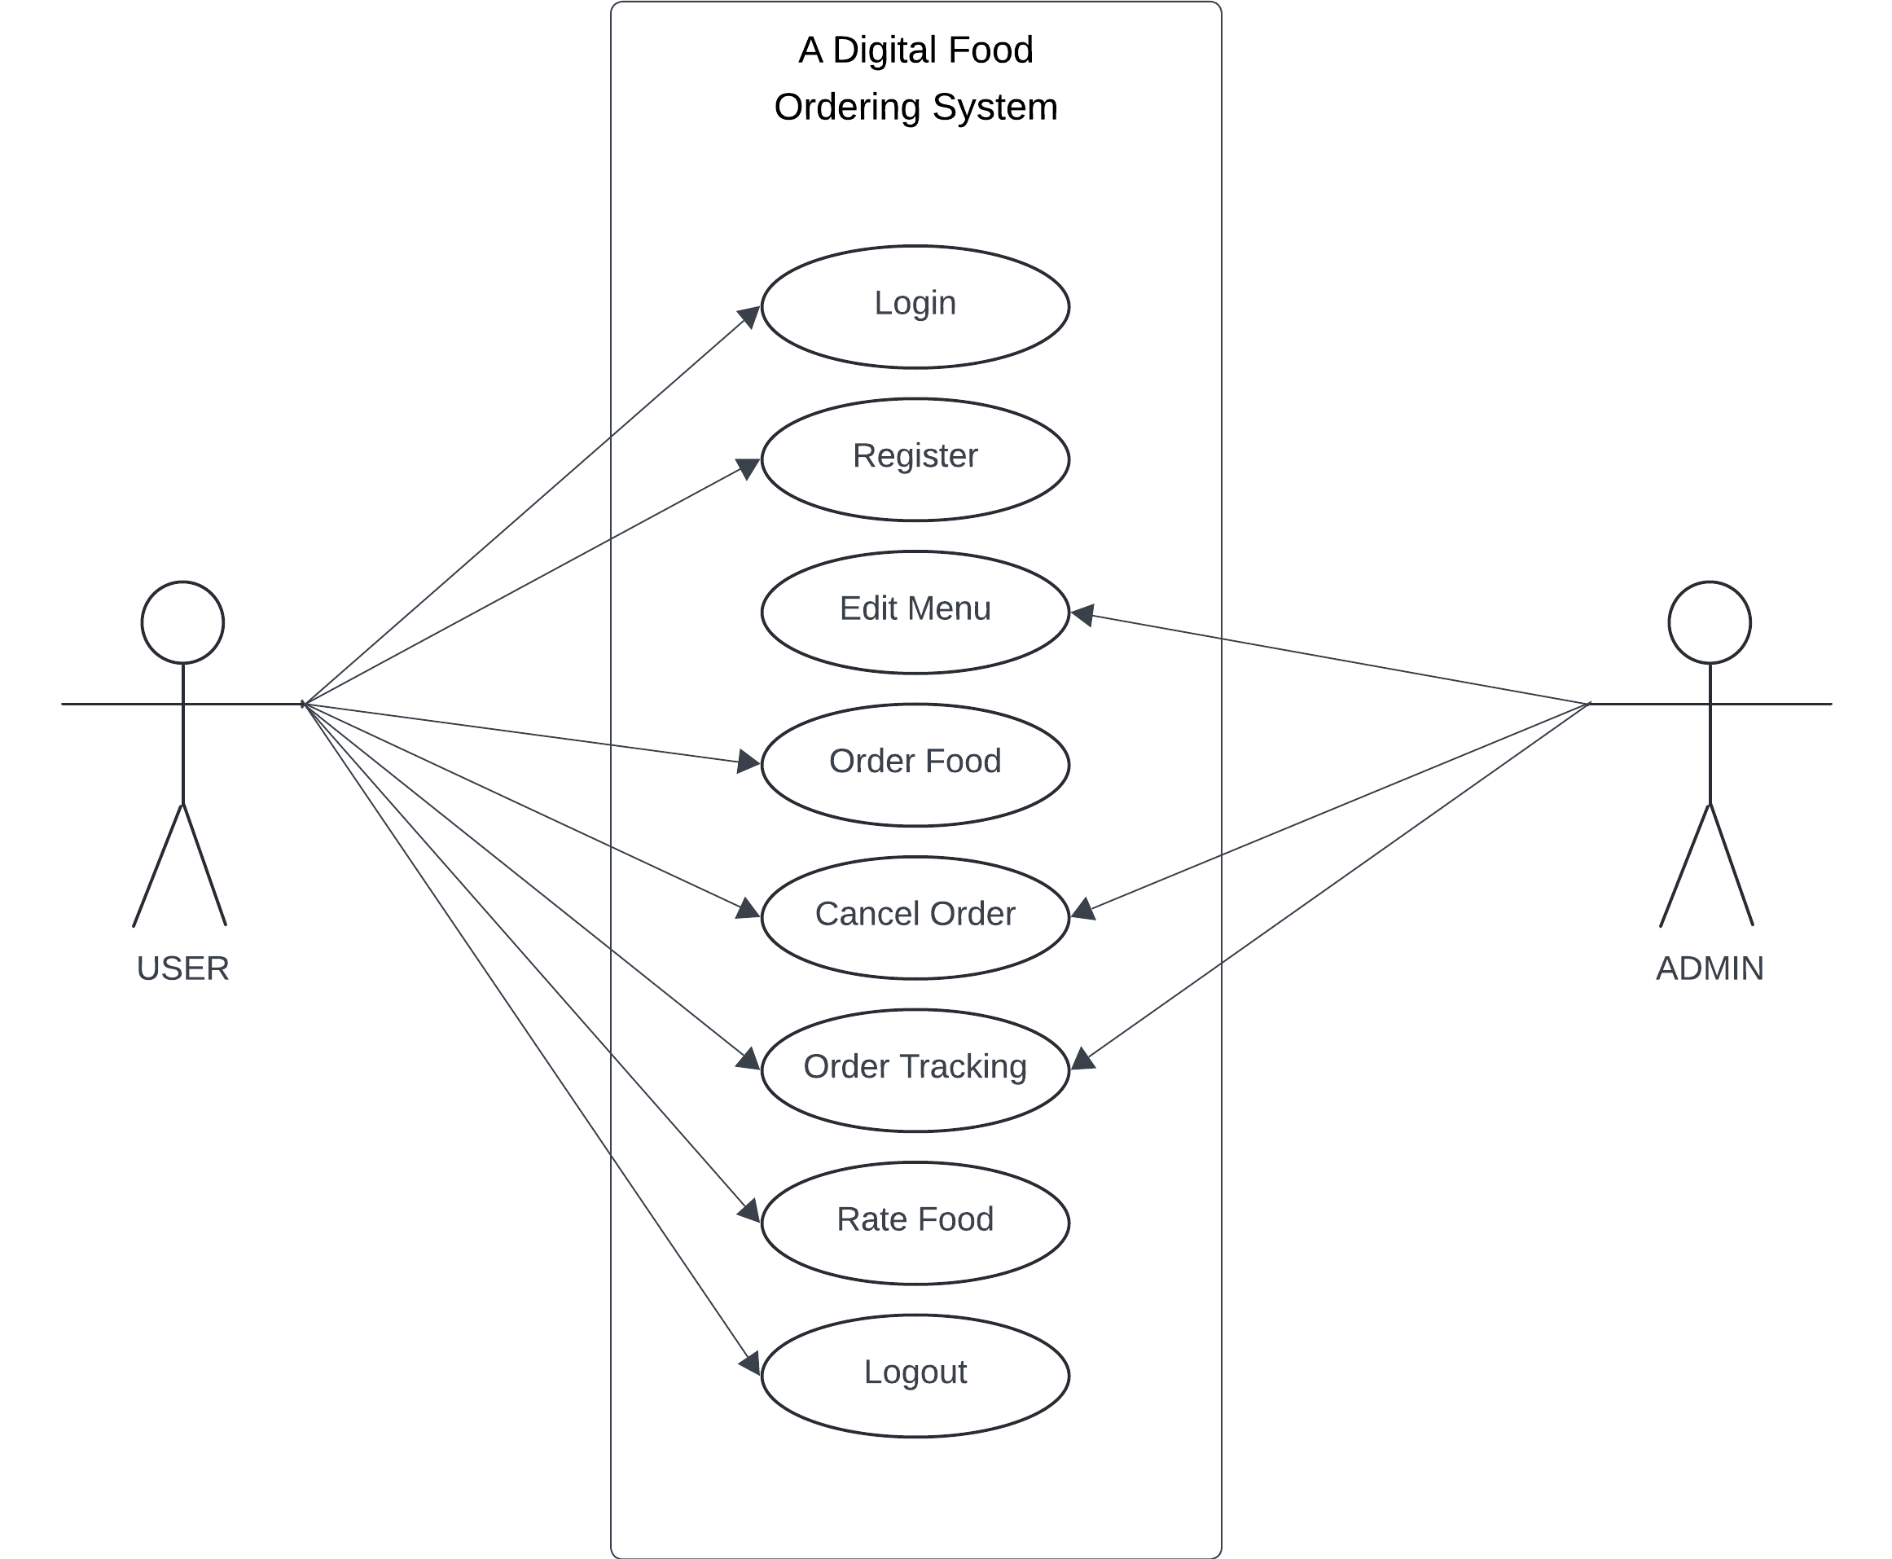

Figure 1: Use case Diagram

1. User Management:

* Register as User: Users can register for an account to access the canteen system.
* Login as User: Any existing user can log in using his credentials.
* Admin Access: Administrators may sign in to manage food items, orders, and system settings.

1. Food Menu Management:

* View Menu: Users are able to see the list of available food items, appropriately categorized.
* Add New Food Item: Admins can add new food items with details including name, price, and category.
* Update Food Item: Admins can update details like price, availability, and description.
* Delete Food Item: Admins can delete food items that are no longer available.

1. Order Management:

* Place Order: User can select food items, add them to the cart, and place an order.
* View Order Queue: Admins and chefs can view the current orders queue for preparation.
* Track Order Status: Allow users to trace the status of their orders, such as ”In Queue”, "In Progress" or "Ready".
* Cancel Order: Users may cancel an order before it starts getting prepared.

1. BILLING AND COMPENSATION:

* The system shows the bill reflecting the food items that have been ordered.
* Track Payment Status: Completed and pending payments can be tracked by admins.

1. Table Management:

* Assign Table Numbers: Users ordering food from their table can link their table number to the order.
* Track Table Orders: This allows waiters and admins to track specific table orders for correct delievery.

1. Tests and Quizzes:

* Add Ratings: Users can rate individual food items they got served.
* View Reviews: Admins and users can view rating about the food items.

1. Reporting and Analysis:

* Order Analysis: Admins can view which food items are most popular.

1. System Management:

* Role-Based Access Control: Different functionalities are available depending on the assigned role (user, waiter, administrator).
* Manage Categories: Only administrators can add, update, or delete food categories.

Data Modeling (ER- Diagram)

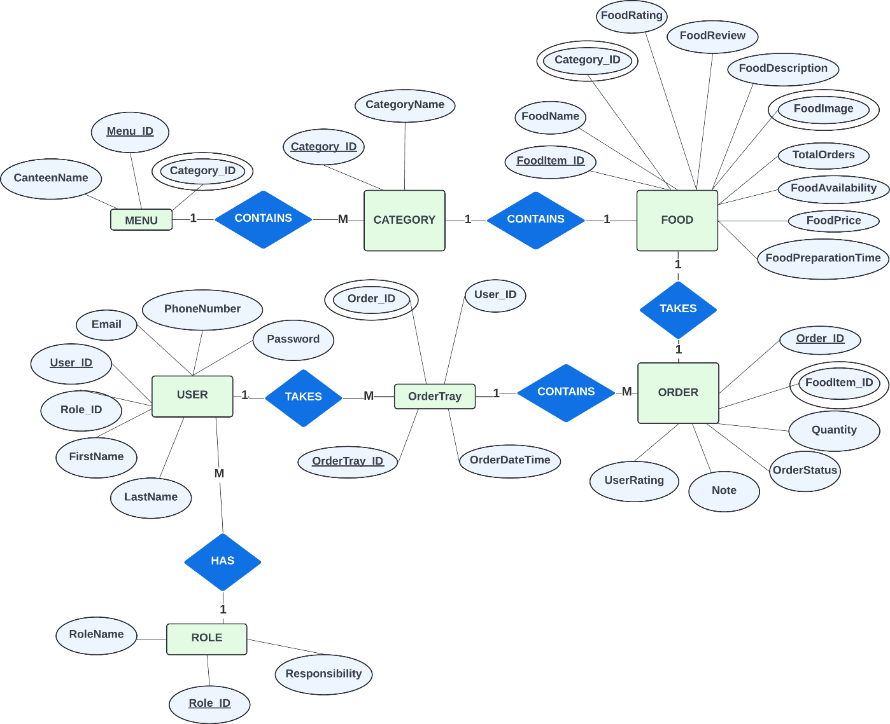

Figure 2: ER Diagram

The ER diagram represents the structure of the digital food ordering system implemented in a canteen or restaurant. The model contains few number of key entities and their relationships, which are very essential in managing the ordering, preparation, and serving processes like basic entities in a digital food ordering system, such as canteens, menus, categories of food, individual items of food, users, roles, order trays, and orders.

Process Modelling (DFD)

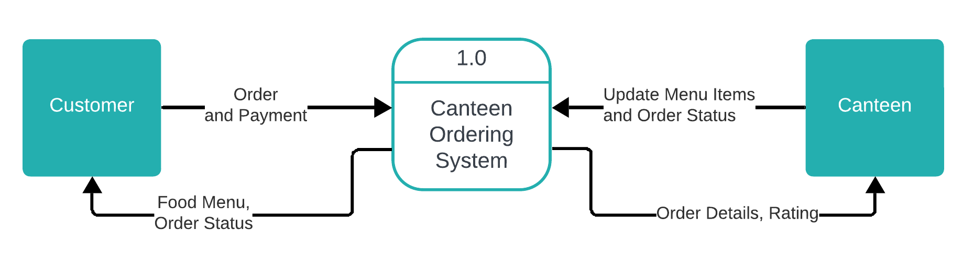

Figure 3: Level 1 DFD

This Level 0 Data Flow Diagram (DFD) describes how people interact with a canteen ordering system. The system assists customers in ordering and making payments. It conveys the customer's order and payment information to the system and further updates the menu and order status with the canteen. The canteen sends the order details and ratings back to the system. This information is then shared with the customer. The diagram shows how data moves between the customer, the canteen ordering system, and the canteen. It highlights the main interactions and data exchanges in the system.

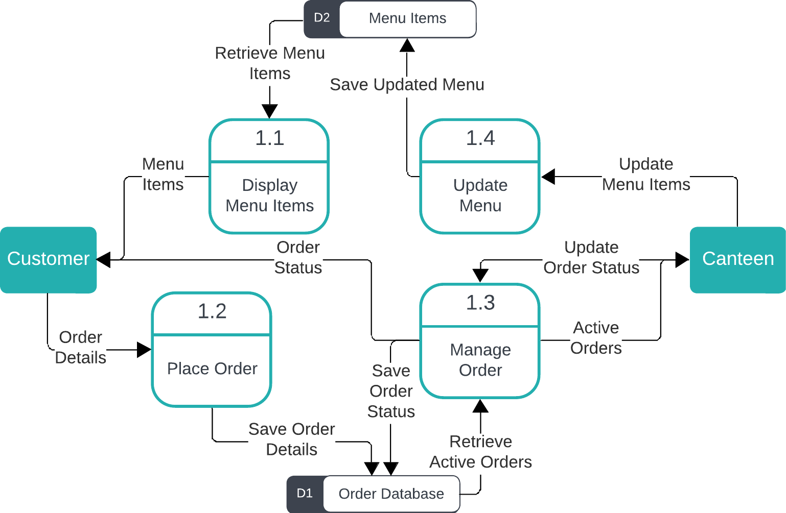

Figure 4 Level 2 DFD

This Level 1 Data Flow Diagram (DFD) shows in detail how a canteen ordering system works. It has four main sub-processes:

**Display Menu Items (1.1):** Retrieves and displays menu items to the customer.

**Place Order (1.2):** Allows the customer to place an order that gets saved in the order database.

**Manage Order (1.3):** Takes care of active orders, retrieves order statuses, and updates the canteen.

**Update Menu (1.4):** Changes the menu items using information from the canteen and saves the new menu.

The diagram shows data movement between the customer, the canteen, the sub-processes, and the data stores involved, viz., Menu Items and Order Database. This explains how orders are placed, managed, and how the menu can be updated, so it remains simple and easy for the ordering process.

## System Design

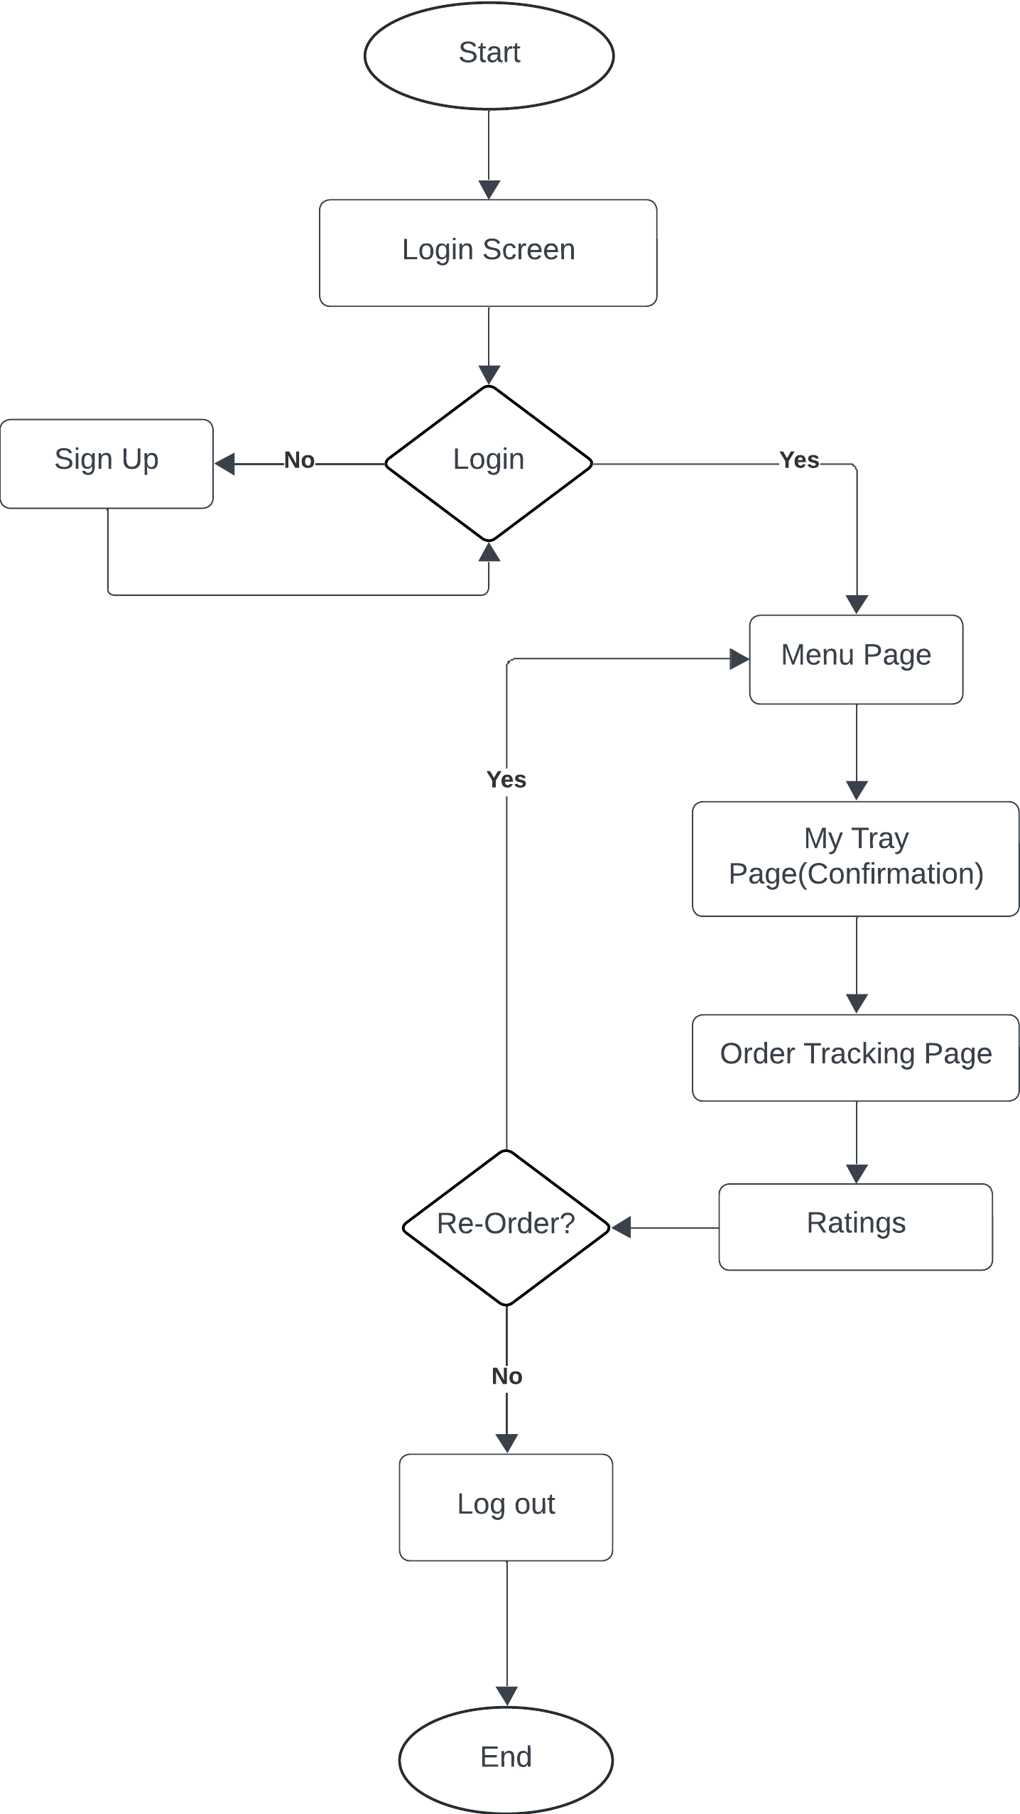

Figure 5 Flow Chart (User)

The flow chart show how the user deals with the system for ordering food for canteen.

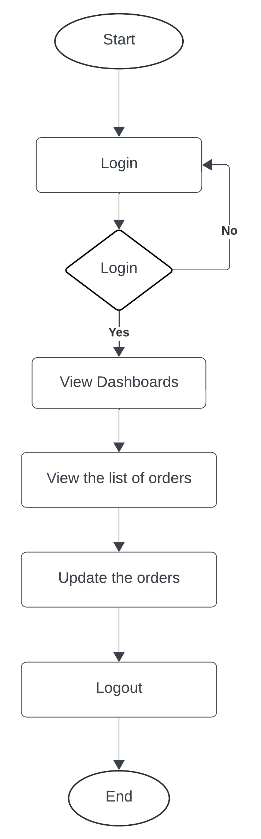

Figure 6: Flow Chart (Admin)

The following Diagram shows how the process goes for the admin for managing and dealing with the orders from customer.

# IMPLEMENTING AND TESTING



## Implementation

Tools Used

**I. CASE Tools**

CASE (Computer-Aided Software Engineering) tools are software tools supporting several phases of the software development process.lifecycles, including requirements gathering, design, coding, testing and maintenance.

**Data Modeling Tools**: Tool like lucidchart can be used to create entity-relationship(ER) diagrams.

**Code Editors and Integrated Development Environments (IDEs):** Visual Studio provide advanced coding features, debugging capabilities, and integration with version control systems to the development of the Smart Serve

**Version Control Systems:** Version control tools such as Git enable collaborative development versioning, and tracking of source code changes

**Documentation tools:** Tools like Microsoft word or Google Docs can be used for creating and maintaining project documentation, including requirements specifications, design documents, and user manuals.

# CONCLUSION AND FUTURE RECOMMENDATION



## Conclusion

In conclusion, the mid-term report of the Smart Serve: The Canteen Order System project shows the progress made and important points addressed during the system's development. This report has covered important areas, including the system's scope, requirements, design, and feasibility analysis.

By the middle of the term, much clarity was achieved regarding both functional and non-functional requirements of the system. The core features of the system, data modeling, and process flow were rightly demonstrated with the help of the use case diagram, ERD, and DFD. These tools gave the project a clear future direction.

Looking forward, Smart Serve is expected to provide a modern, user-friendly platform for canteen order management. With automated ordering, payment, and delivery, the system will improve the customer experience and make operations smoother, ultimately giving real benefits to its users.

# REFERENCES

[1] A. Jadhav, Tejashri Adsure, A. Kamble, Ajay Dhakane, and Sumit Karanjkar, “A Comprehensive Survey on Digitization in Restaurant Sector,” pp. 1–6, May 2024, doi: https://doi.org/10.1109/raics61201.2024.10689768.

‌[2] K. Ashish, A. S. Rathour, A. Banerjee, and B. Machhi, “The Culinary Revolution in Your Pocket: The Influence of Food Ordering Apps on Restaurants”, *IJRESM*, vol. 7, no. 3, pp. 56–61, Mar. 2024, Accessed: Dec. 01, 2024. [Online]. Available: <https://journal.ijresm.com/index.php/ijresm/article/view/2966>

[3] W. Leong, Hong, U. Tunku, and A. Rahman, “Food Ordering System Using Mobile Phone A REPORT SUBMITTED TO,” 2016. Available: <http://eprints.utar.edu.my/1943/1/IA-2016-1203135-1.pdf>

[4] “(PDF) Customers’ technology readiness and customer information satisfaction on tablet-based menu ordering experience,” *ResearchGate*. <https://www.researchgate.net/profile/Mohd-Hanafiah/publication/314976946_Customers>

[5] C.-C. Wong, L.-Y. Chong, S.-C. Chong, and C.-Y. Law, “QR Food Ordering System with Data Analytics,” *Journal of Informatics and Web Engineering*, vol. 2, no. 2, pp. 249–272, Sep. 2023, doi: https://doi.org/10.33093/jiwe.2023.2.2.18.

‌

‌

‌

# APPENDICES

|  |  |  |
| --- | --- | --- |
| Register page | Login Page | Menu Page |
|  |  |  |

|  |  |  |
| --- | --- | --- |
| My Tray Page | Order Tracking Page | Order Monitor(Admin) |
|  |  |  |

Order monitor (admin)

